**Electric Bill System Database**

**EER DIAGRAM**

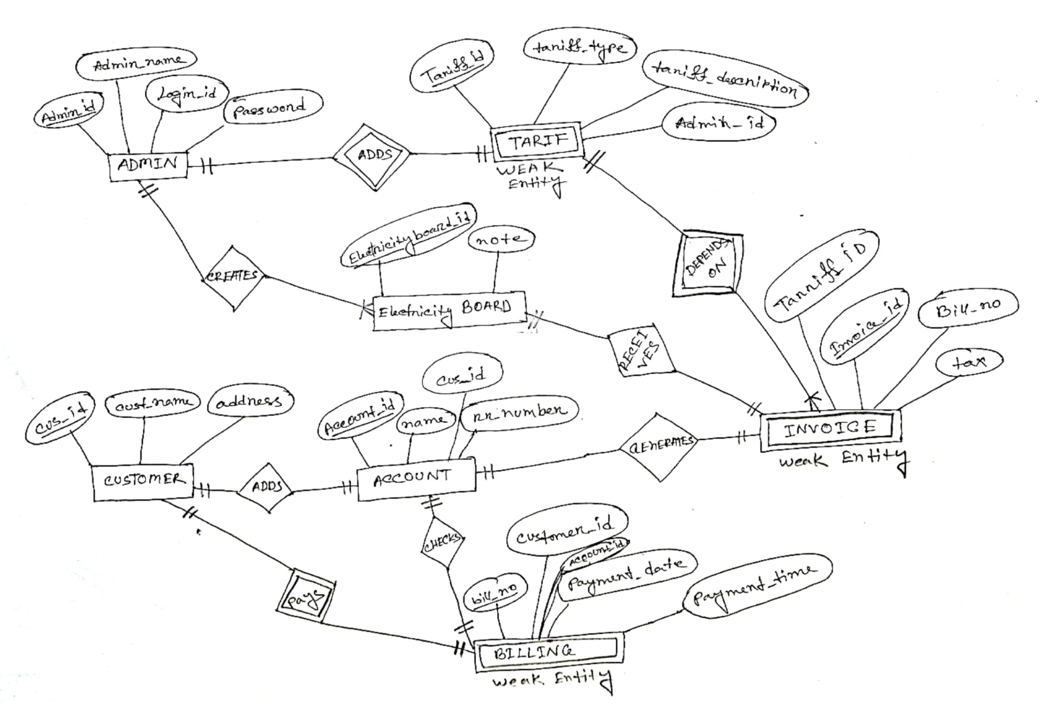

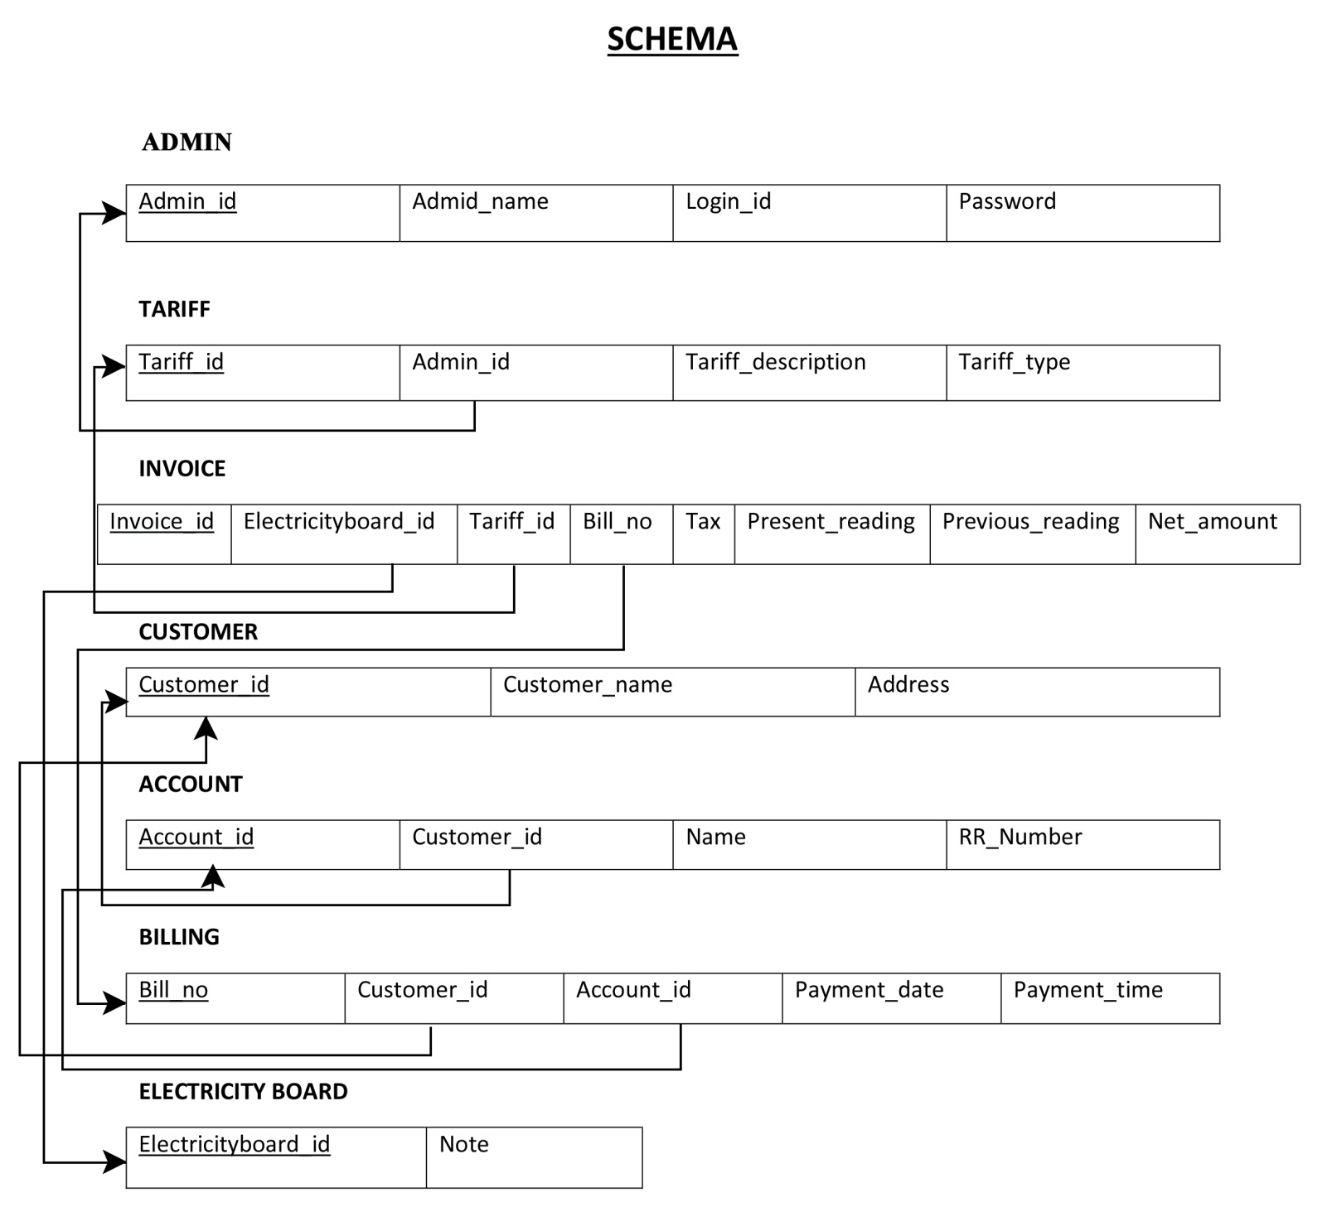

**SQL statements**

create database electricity_bill_system;

use electricity_bill_system;

**ADMIN**

CREATE TABLE admin (

Admin_id varchar(15) NOT NULL,

Admin_name varchar(15) NOT NULL,

Login_id varchar(15) NOT NULL,

Password varchar(50) NOT NULL,

PRIMARY KEY (Admin_id)

);

**OUTPUT:**

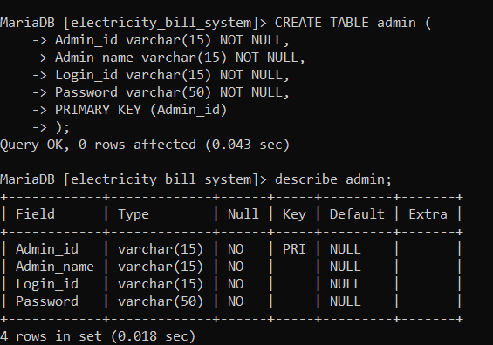

**INSERT DATA INTO ADMIN:**

insert into admin(Admin_id, Admin_name, Login_id, Password)

values

('EBS-201101', 'Jones', 'Jones201101', '01Jones201101'),

('EBS-201102', 'Smith', 'Smith201102', '02Smith201102'),

('EBS-201103', 'Hayes', 'Hayes201103', '03Hayes201103'),

('EBS-201104', 'Curry', 'Curry201104', '04Curry201104'),

('EBS-201105', 'Lindsay', 'Lindsay201105', '05Lindsay201105');

select * from admin;

**Format:**

**insert into admin(Admin_id, Admin_name, Login_id, Password)**

**values**

**(‘Insert admin ID here', 'Insert admin name here', 'Insert Admin login ID here', 'Insert admin password here');**

**OUTPUT:**

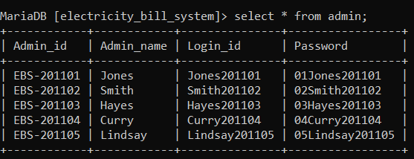

**TARIFF**

CREATE TABLE tariff (

Tariff_id varchar(15) NOT NULL,

Admin_id varchar(15) NOT NULL,

Tariff_description varchar(255),

Tariff_type varchar(15),

PRIMARY KEY (Tariff_id),

FOREIGN KEY (Admin_id) REFERENCES admin(Admin_id)

);

**OUTPUT:**

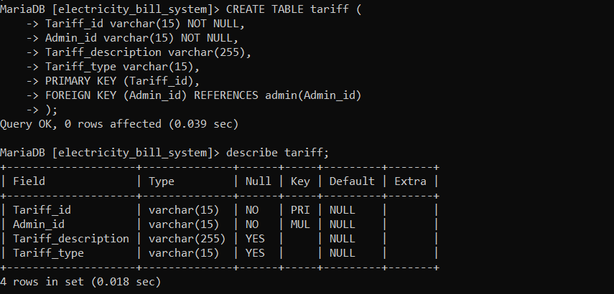

**INSERT DATA INTO TARIFF:**

insert into tariff(Tariff_id, Admin_id, Tariff_description, Tariff_type)

values

('TID-01', 'EBS-201101', '3.75 tk per unit', 'Low (0-150 unit)'),

('TID-02', 'EBS-201102', '4.19 tk per unit', 'Medium (151-300 unit)'),

('TID-03', 'EBS-201104', '6.34 tk per unit', 'High (301-600 unit)'),

('TID-04', 'EBS-201105', '12.50 tk per unit', 'Platinum(600+ unit)');

select * from tariff;

**FORMAT:**

**insert into tariff(Tariff_id, Admin_id, Tariff_description, Tariff_type)**

**values**

**('Insert Tariff id here', 'Insert Admin ID here', 'Insert Tariff description fere', 'Insert Tariff type here');**

**OUTPUT:**

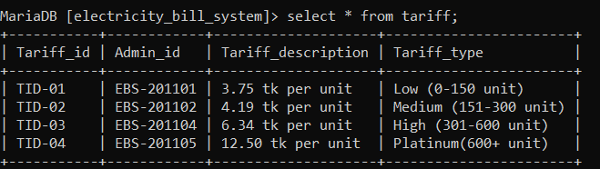

**INVOICE**

CREATE TABLE invoice (

Invoice_id varchar(15) NOT NULL,

Electricity_board_id varchar(15) NOT NULL,

Tariff_id varchar(15) NOT NULL,

Bill_no varchar(15) NOT NULL,

Tax_taka FLOAT,

Present_reading_unit FLOAT,

Previous_reading_unit FLOAT,

Net_amount_taka FLOAT,

PRIMARY KEY (Invoice_id),

FOREIGN KEY (Electricity_board_id) REFERENCES electricity_board(Electricity_board_id),

FOREIGN KEY (Tariff_id) REFERENCES tariff(Tariff_id),

FOREIGN KEY (Bill_no) REFERENCES billing(Bill_no)

);

**OUTPUT:**

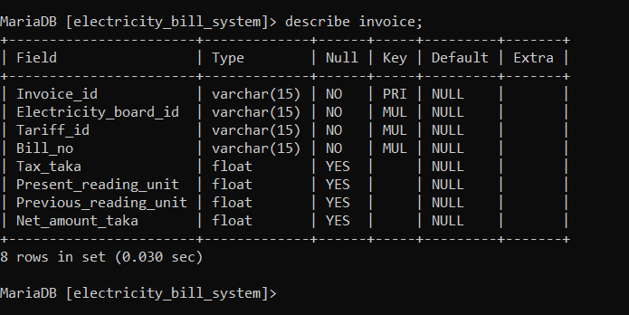

**INSERT DATA INTO INVOICE:**

insert into invoice(Invoice_id, Electricity_board_id, Tariff_id, Bill_no, Tax_taka, Present_reading_unit, Previous_reading_unit, Net_amount_taka)

values

('INV-001', 'EBID0001', 'TID-01', '201101400', '34', '367850', '367750', '409'),

('INV-002', 'EBID0002', 'TID-03', '201101401', '45', '427336', '427026', '2010.4'),

('INV-003', 'EBID0003', 'TID-02', '201202402', '40', '253912', '253650', '1137.78'),

('INV-004', 'EBID0004', 'TID-04', '201202403', '55', '361858', '361295', '3624.42'),

('INV-005', 'EBID0005', 'TID-01', '201903404', '34', '12305', '12200', '491.75'),

('INV-006', 'EBID0006', 'TID-03', '202004405', '45', '11606', '11300', '1985.04');

select * from invoice;

**FORMAT:**

insert into invoice(Invoice_id, Electricity_board_id, Tariff_id, Bill_no, Tax_taka, Present_reading_unit, Previous_reading_unit, Net_amount_taka)

values

('Insert Invoice_id here ', ' Insert Electricity_board_id here', 'Insert Tariff_id here', 'Insert Bill_no here', 'Insert Tax_taka here', 'Insert Present_reading_unit here', 'Insert Previous_reading_unit here', ' Insert Net_amount_taka here');

**OUTPUT:**

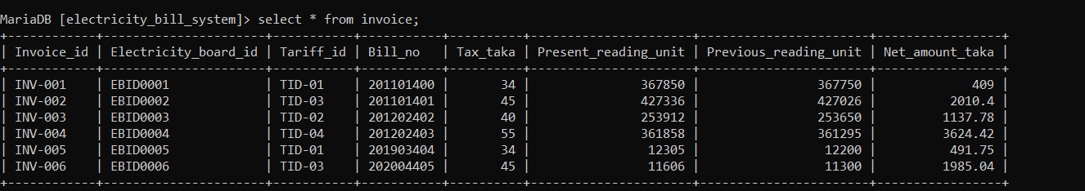

**CUSTOMER**

CREATE TABLE customer (

Customer_id varchar(15) NOT NULL,

Customer_name varchar(25) NOT NULL,

Address varchar(50),

PRIMARY KEY (Customer_id)

);

**OUTPUT:**

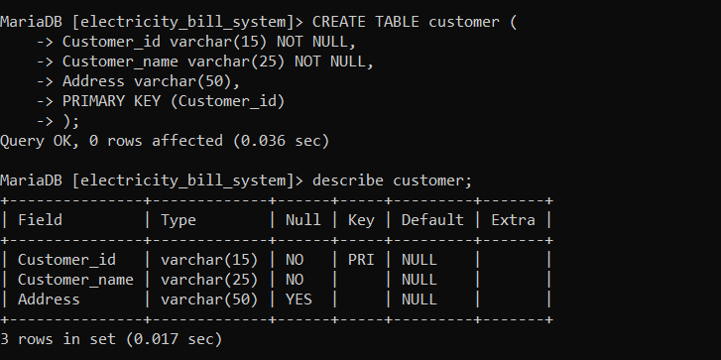

**INSERT DATA INTO CUSTOMER:**

insert into customer(Customer_id, Customer_name, Address)

values

('24682101', 'Niloy Sen', 'Banani'),

('24682102', 'Tarek', ' Uttara'),

('24682103', 'Sumsul Islam', 'Banani'),

('24682104', 'Nahidul Hoque', 'Gulshan-1'),

('24682105', 'Sanjita Roy', 'Gulshan-2'),

('24682106', 'Shariful Islam', 'Uttara');

select * from customer;

**FORMAT:**

insert into customer(Customer_id, Customer_name, Address)

values

('Insert Customer_id here ', 'Insert Customer_name here', 'Insert Address here');

**Output:**

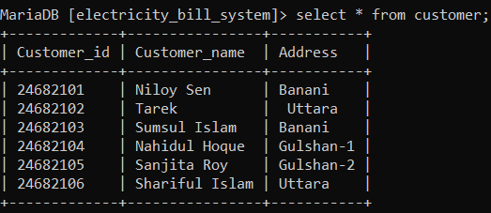

**ACCOUNT**

CREATE TABLE account (

Account_id varchar(15) NOT NULL,

Customer_id varchar(15) NOT NULL,

Name varchar(25),

RR_number varchar(20),

PRIMARY KEY (Account_id),

FOREIGN KEY (Customer_id) REFERENCES customer(Customer_id)

);

**OUTPUT:**

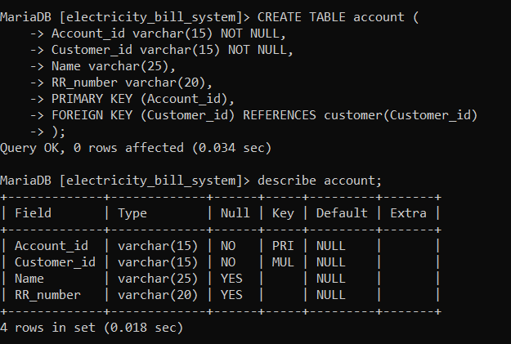

**INSERT DATA INTO ACCOUNT:**

insert into account(Account_id, Customer_id, Name, RR_number)

values

('201124682101', '24682101', 'Niloy Sen', 'BNN201'),

('201124682102', '24682102', 'Tarek', 'UTT101'),

('201224682103', '24682103', 'Sumsul Islam', 'BNN202'),

('201224682104', '24682104', 'Nahidul Hoque', 'GLN301'),

('201924682105', '24682105', 'Sanjita Roy', 'GLN401'),

('202024682106', '24682106', 'Shariful Islam', 'UTT102');

select * from account;

**FORMAT:**

**insert into account(Account_id, Customer_id, Name, RR_number)**

**values**

**('Insert Account_id here', 'Insert Customer_id here', Insert Name here', 'Insert RR_number here');**

**OUTPUT:**

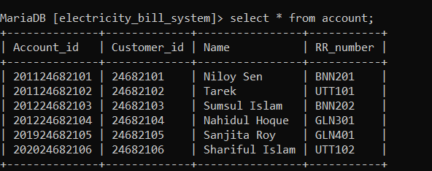

**BILLING**

CREATE TABLE billing (

Bill_no varchar(15) NOT NULL,

Customer_id varchar(15) NOT NULL,

Account_id varchar(15) NOT NULL,

Payment_date DATE,

Payment_time TIME,

PRIMARY KEY (Bill_no),

FOREIGN KEY (Customer_id) REFERENCES customer(Customer_id),

FOREIGN KEY (Account_id) REFERENCES account(Account_id)

);

**OUTPUT:**

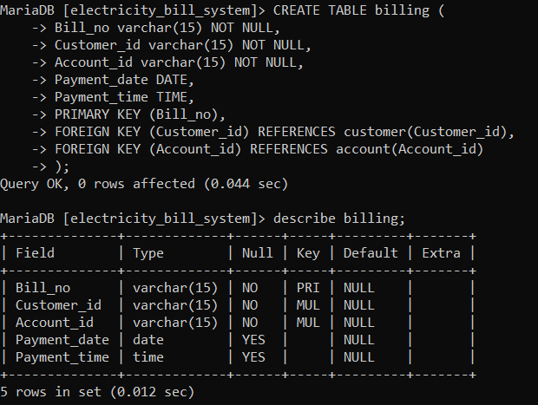

**INSERT DATA INTO BILLING:**

insert into billing(Bill_no, Customer_id, Account_id, Payment_date, Payment_time)

values

('201101400', '24682101', '201124682101', '2021-12-09', '09:15:00'),

('201101401', '24682102', '201124682102', '2021-12-10', '11:25:00'),

('201202402', '24682103', '201224682103', '2021-12-12', '14:34:00'),

('201202403', '24682104', '201224682104', '2021-12-14', '13:45:00'),

('201903404', '24682105', '201924682105', '2021-12-25', '10:12:00'),

('202004405', '24682106', '202024682106', '2021-12-29', '15:30:00');

select * from billing;

**FORMAT:**

insert into billing(Bill_no, Customer_id, Account_id, Payment_date, Payment_time)

values

('Insert Bill_no here', 'Insert Customer_id here', 'Insert Account_id here', 'Insert Payment_date here', 'Insert Payment_time here');

**OUTPUT:**

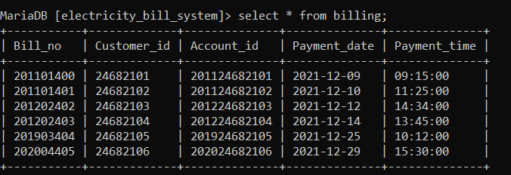

**ELECTRICITY BOARD**

CREATE TABLE electricity_board (

Electricity_board_id varchar(15) NOT NULL,

Note varchar(50),

PRIMARY KEY (Electricity_board_id)

);

**OUTPUT:**

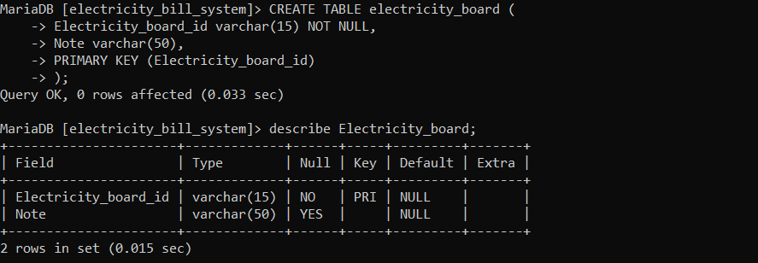

**INSERT DATA INTO ELECTRICITY BOARD**

insert into electricity_board(Electricity_board_id, Note)

values

('EBID0001', 'Residential Area'),

('EBID0002', 'Residential Area'),

('EBID0003', 'Residential Area'),

('EBID0004', 'Residential Area'),

('EBID0005', 'Residential Area'),

('EBID0006', 'Residential Area');

select * from electricity_board;

**FORMAT:**

**insert into electricity_board(Electricity_board_id, Note)**

**values**

**('Insert Electricity_board_id here', 'Insert Note here');**

**UPDATE ADMIN INFORMATION**

UPDATE admin

SET Admin_name = 'Type new name here',

Login_id = 'Type new Login_id here',

Password= 'Type new Password here'

WHERE Admin_id = 'Type the Admin id which data you want to change';

select * from admin;

**UPDATE TARIFF INFORMATION**

UPDATE tariff

SET Tariff_description = 'Type new descriptio here',

Tariff_type = 'Type new Tariff_type here'

WHERE Tariff_id = 'Type the Tariff_id which data you want to change';

select * from tariff;

**UPDATE INVOICE INFORMATION**

UPDATE invoice

SET Tax_taka = 'Type new Tax here',

Present_reading_unit = 'Type new present reading unit here'

Previos_reading_unit = 'Type new previous reading unit here'

WHERE Invoice_id = 'Type the invoice id which you want to change';

select * from invoice;

**UPDATE CUSTOMER INFORMATION**

UPDATE customer

SET Customer_name = 'Type new name here',

Address = 'Type new adress here'

WHERE Customer_id= 'Type the Customer id which data you want to change';

select * from customer;

**UPDATE ACCOUNT INFORMATION**

UPDATE account

SET Name = 'Type new name here',

RR_Number = 'Type new RR_Number here'

WHERE Accunt_id= 'Type the Account id which data you want to change';

select * from account;

**UPDATE BILLING INFORMATION**

UPDATE billing

SET Payment_date = 'Type new Payment_date here',

Payment_time = 'Type new Payment_time here'

WHERE Bill_no= 'Type the Bill_no which data you want to change';

select * from billing;

**UPDATE ELECTRICITY BOARD INFORMATION**

UPDATE electricity_board

SET Electricityboard_id = 'Type new electricity board id here',

Note = 'Type new Note here'

WHERE Electricityboard_id = 'Type the Electricityboard_id which data you want to change';

select * from electricity_board;

**DELETE ADMIN INFORMATION**

Delete FROM admin

WHERE Admin_id = 'Type the admin id which data you want to delete';

select * from admin;

**DELETE TARIFF INFORMATION**

Delete FROM tariff

WHERE Tariff_id = 'Type the tariff id which data you want to delete';

select * from tariff;

**DELETE INVOICE INFORMATION**

Delete FROM invoice

WHERE Invoice_id = 'Type the invoice id which data you want to delete';

select * from invoice;

**DELETE CUSTOMER INFORMATION**

Delete FROM customer

WHERE Customer_id = 'Type the Customer id which data you want to delete';

select * from customer;

**DELETE ACCOUNT INFORMATION**

Delete FROM account

WHERE Account_id = 'Type the Account id which data you want to delete';

select * from account;

**DELETE BILLING INFORMATION**

Delete FROM billing

WHERE Bill_no = 'Type the Bill no which data you want to delete';

select * from billing;

**DELETE ELECTRICITY BOARD INFORMATION**

Delete FROM electricity_board

WHERE Electricityboard_id = 'Type Electricityboard_id which data you want to delete';

select * from electricity_board;

1. Find the customer's name whose address is banani ?

Select Customer_name

From Customer

Where address = “Banani”;

**Output:**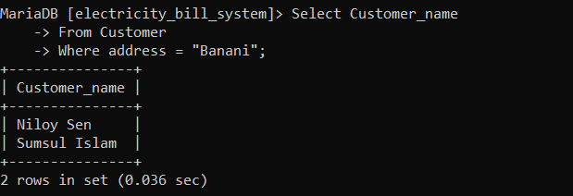

1. Find the customer's id and customer's name whose payment time is 15:30:00 ?

SELECT Customer_name

FROM Customer C, billing B

WHERE C.Customer_id = B.Customer_id

AND Payment_time = “15:30:00”;

**Output:**

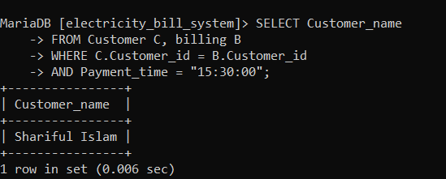

1. FInd the admin name and password from the tariff Description ?

SELECT Admin_name , Password

FROM ADMIN A , TARIFF T

WHERE A.Admin_id = T.Admin_id

AND Tariff_description ;

**Output:**

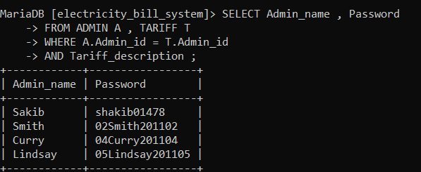

1. Find the names and addresses who have bill no 201202403 ?

SELECT Customer_name ,Address

FROM Customer C, billing B

WHERE C.Customer_id = B.Customer_id

AND Bill_no = “201202403”;

**OUTPUT:**

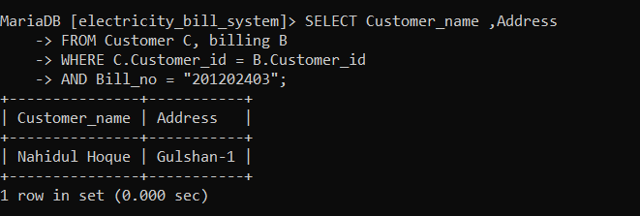

1. Find the bill_no who gives payment between 09-12-2021 to 14-12-2021?

Select Bill_no

From billing

Where Payment_date between “2021-12-09”and “2021-12-04”;

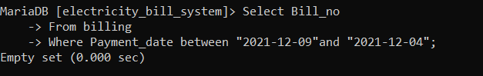

1. Find the customers name whose name ending is Islam?

select customer_name

from customer

where customer_name like “%Islam%”

**OUTPUT:**

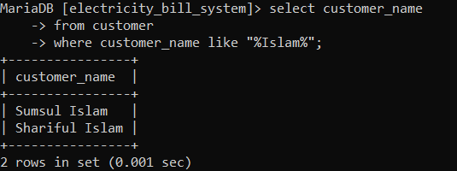

1. Find the Tariff id whose net amount is greater than 1137.78 TK?

SELECT Tariff_id

FROM INVOICE

WHERE Net_amount_taka > “1137.78”

**OUTPUT:**

